Endometriosis Awareness Programme
An “Endometriosis Awareness Programme" was organized by the Obstetrics & Gynaecology Department, AIIMS Raipur in collaboration with ICMR-NIRRCH Mumbai on 27.03.2023 in the OPD area to spread awareness about Endometriosis among the common masses.
The Programme was attended by OPD Patients, faculty, Postgraduate students, Interns, Nursing student, Nursing officer staff, research assistant, and all the staff members of the dept. of OBGY AIIMS Raipur.
The Programme was inaugurated by Chief Guest Prof Dr. Nitin M Nagarkar sir, Director, AIIMS Raipur, and Guest of honor, Prof. Dr Sarita Agrawal, HOD, Dean Research, AIIMS Raipur, with lighting of the holy lamp.
As an Organizing Chairperson Dr Nilaj Bagde, Additional Professor in Obstetrics & Gynaecology Department welcomed the dignitaries and audience and emphasized why Endometriosis Awareness is the need of the hour. He informed that endometriosis is an enigmatic disease that affects women mostly between the age of 15 to 44 years with a high prevalence of affecting every one female out of 10 in Worldwide. He also explained about the pathogenesis behind the occurrence of the disease, its symptoms and the need for early approach to health care. He further emphasized that a “Endometrioses specialty OPD” is available on every Thursday at Dept of OBGY AIIMS Raipur
An excellent poster presentation competition was conducted for the Nursing officer staff earlier and their posters were displayed during the programme depicting the endometriosis disease, etiology, symptoms, severity, need for early detection, and treatment of endometriosis. A similar video was made compiling the latest statistics and clear description of the disease by a group of staff nurse.
Honorable Chief Guest of the event Prof. Dr Nitin M Nagarkar addressed the audience and expressed his delight at the Obstetrics & Gynaecology Department contribution towards Endometriosis awareness. He highlighted how such small steps can break the cycle of disease and led us to healthy happy and prosperous future. He motivated the common public to work together to build a healthy India. He also emphasized the importance of government institutes in providing awareness and building research in such highly prevalent diseases.
Prof Dr Sarita Agrawal, HOD of Obstetrics & Gynaecology Department, has appreciated the effort by the Organizing chairperson Dr Nilaj Bagde, in illuminating the faculty, nursing staff and all the women attending the OBGY OPD, regarding the need of the hour. Also, his efforts in other fields were admired. She further enlightened the women regarding the disease and regular follow up with their doctors on noticing any symptoms and taking complete treatment.
The Poster presentation competition winners were felicitated by the Chief Guest and a Certificate of participation was provided to the other contestants.
In the same event, an information booklet regarding endometriosis disease in hindi language was launched by the Prof Dr Nitin M Nagarkar and this booklet was distributed among the audience. The booklet was very educative regarding the prevalence, symptoms, investigations and treatment of the disease.
A similar event was conducted in Samudaik Swasthya Kendra, Raipura, Raipur on 24.03.23 with participation of local female in large numbers and followed by an interactive Q&A session.
A vote of thanks was given by Dr Loukiya and the entire programme was concluded with a positive energy and better informed audience. Overall it was a very interactive and knowledgeable event. Nearly 150 women were enlightened through this event and we are sure even more will be enlightened from them.

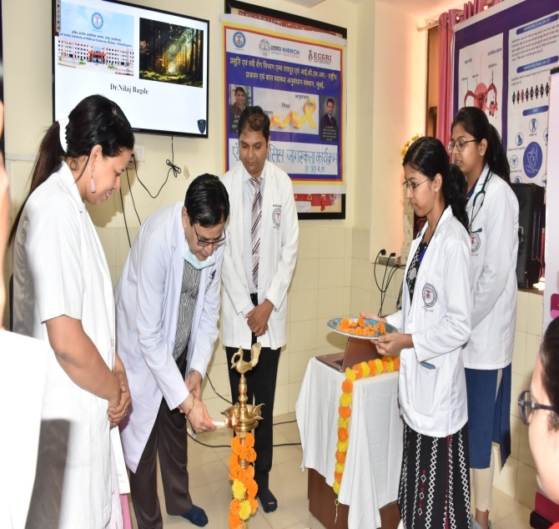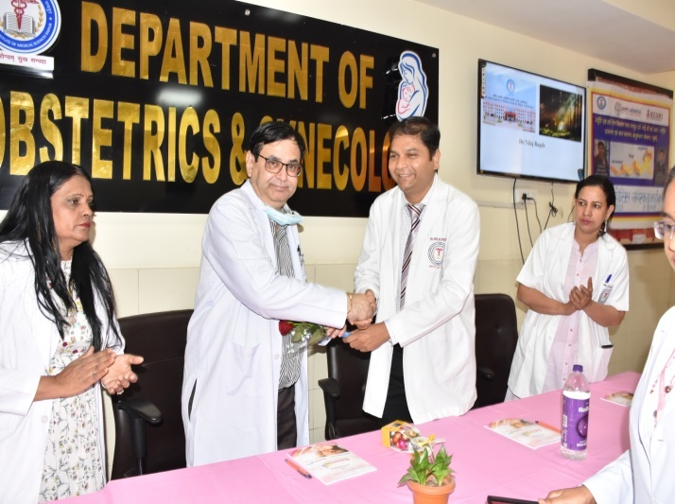
Lighting of the holy Lamp

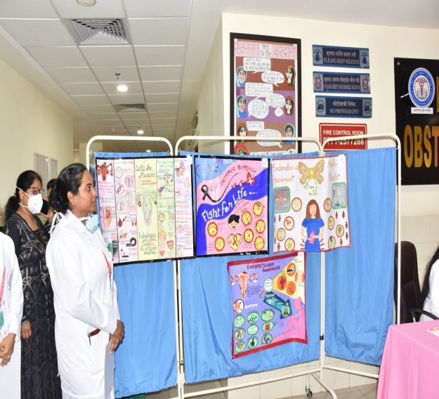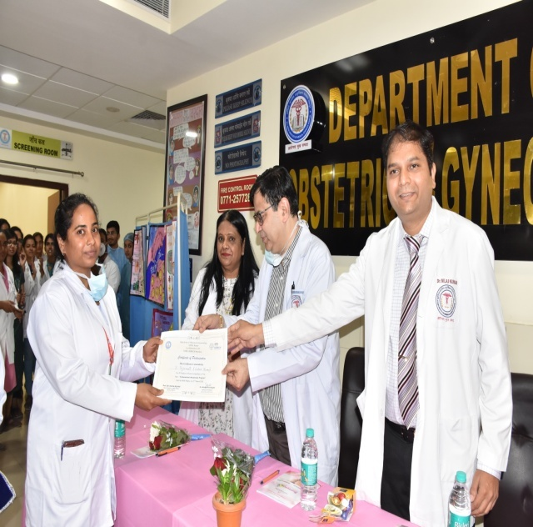
Poster presentation by nursing officer & Certificate distribution
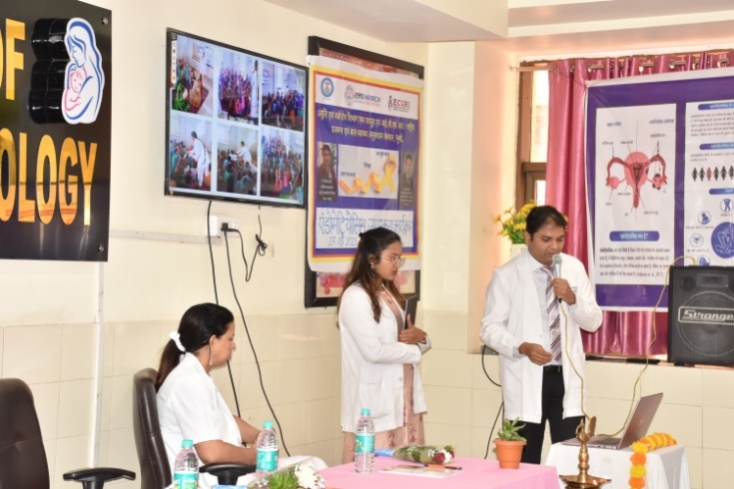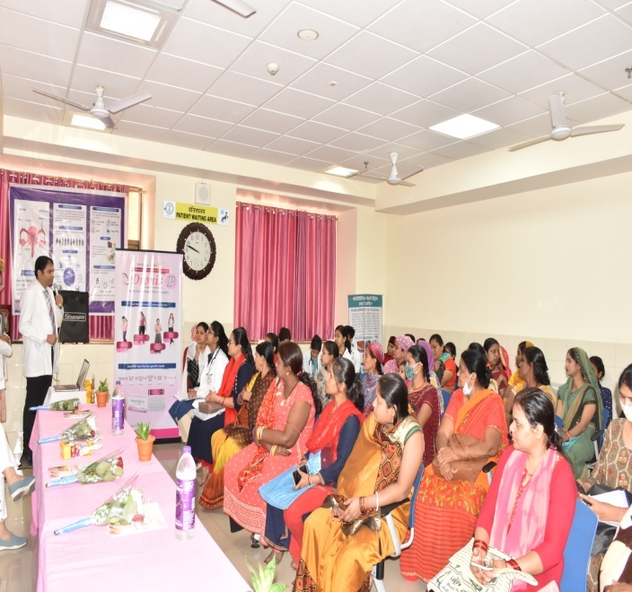

Health Awareness talk on Endometriosis by Dr. Nilaj Bagde

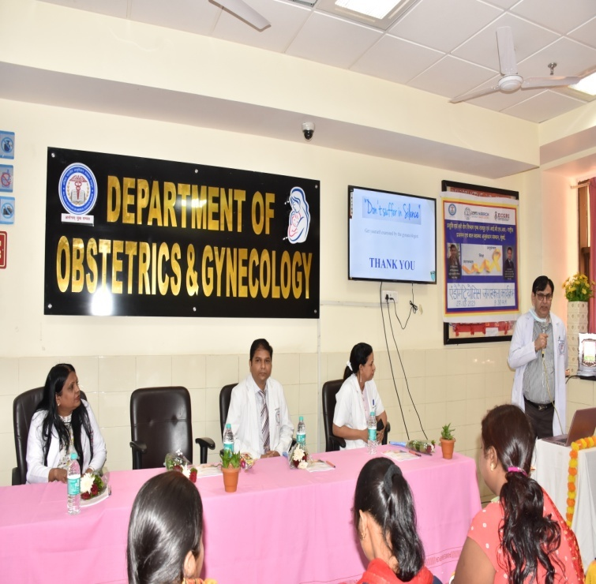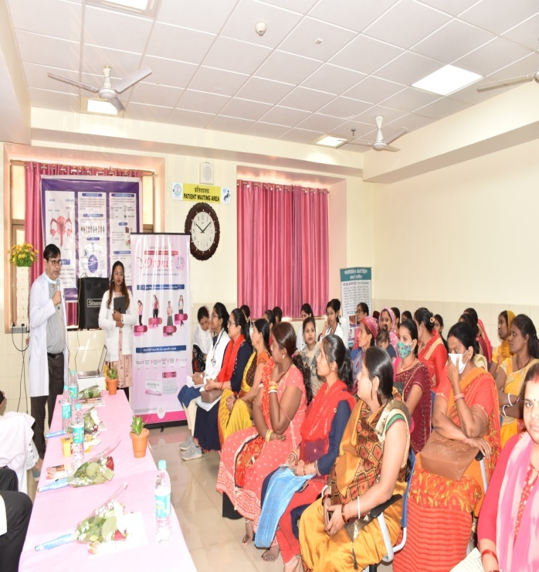
Speech Delivered by Honorable Chief Guest Prof Dr. Nitin M Nagarkar Sir, Director, AIIMS Raipur,

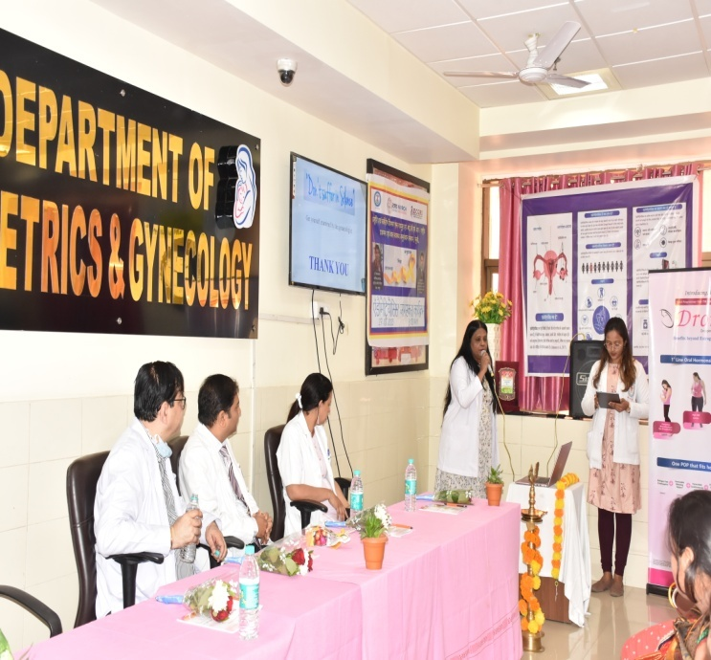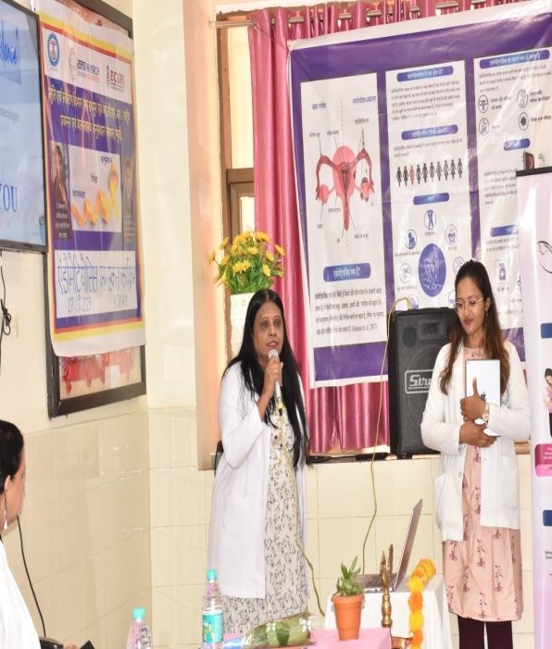
Speech Delivered by Guest of honor Prof Dr. Sarita Agrawal, HOD, Dean Research, AIIMS Raipur,

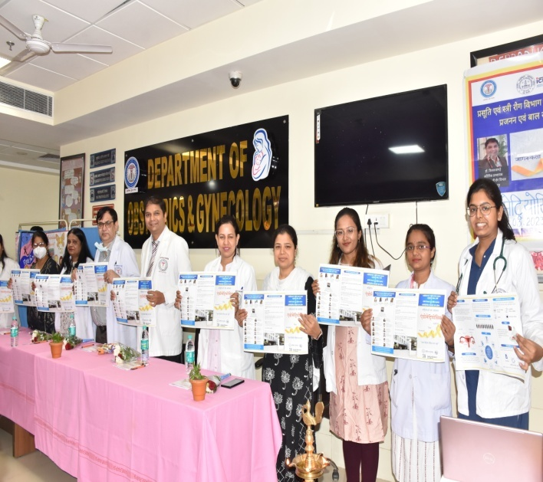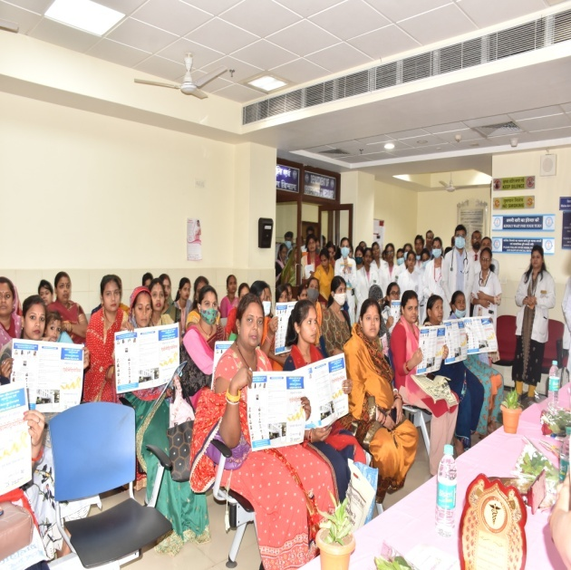

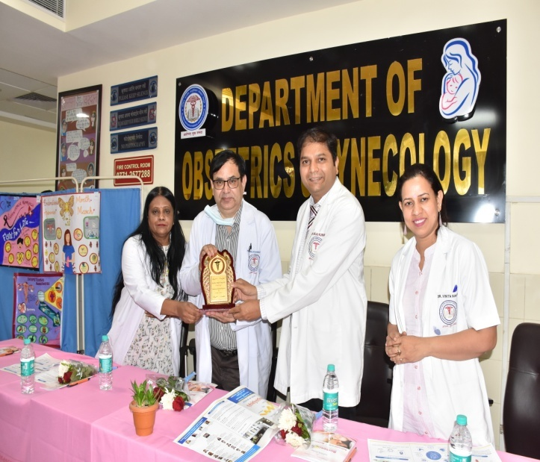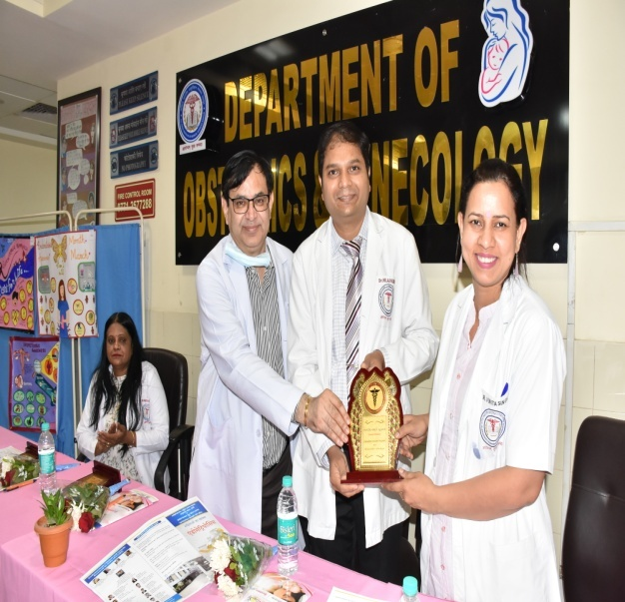

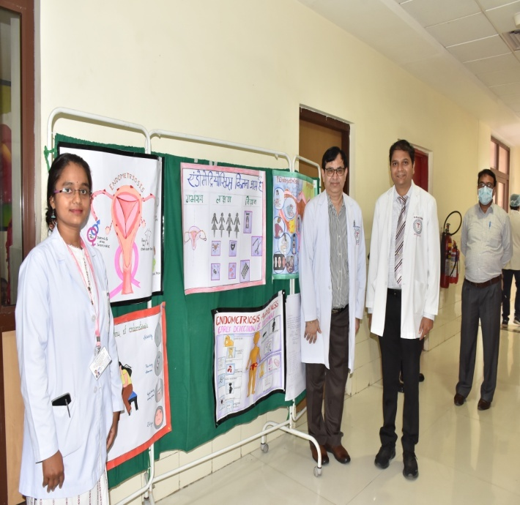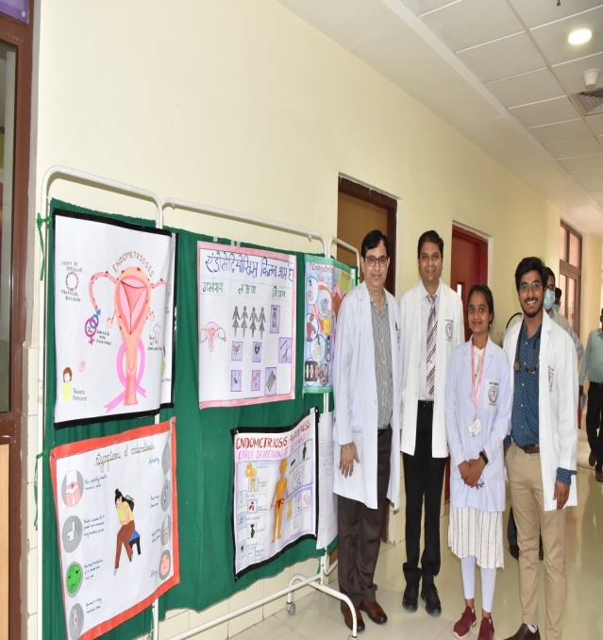

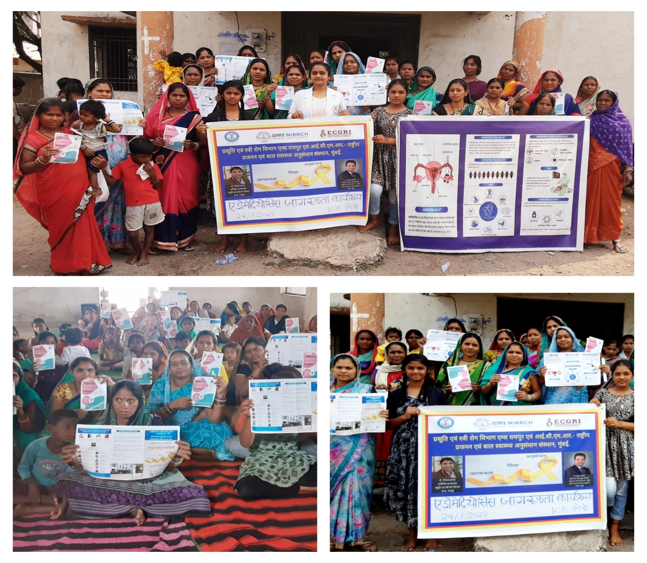
Endometriosis awareness program Conducted in Samudaik Swasthya Kendra, Raipura, Raipur on 24.03.2023 with participation of local female.

